**Exercise 2: Installing and Configuring the Virtual Machine**

In this exercise, you will learn how to install and configure a Web Server in the Linux Virtual Machine by using a SSH client. First, you will install the Apache Web server and the MySQL database server by using Yast2 application. Then, you will configure the Virtual Machine and create an example database.

**Note:** If you have not run Exercise 1, make sure you have the following items ready before proceeding with Exercise 2:

* A Linux Virtual Machine created in Microsoft Azure Portal.
* A TCP Endpoint enabled with private port 22.
* A TCP Endpoint enabled in port 80.

**Task 1 - Installing and Configuring Apache and MySQL**

In this task, you will install and configure an Apache HTTP Server and MySQL Database Management System.

1. In the terminal, execute the following commands to install the required packages.
2. sudo apt-get update
3. sudo apt-get upgrade
4. sudo apt-get install lamp-server^
5. **Note**: If you get the following prompt "Do you want to reject the key, trust temporarily, or trust always? [r/t/a/?]", press **A** and then **Enter**. Pattern Lamp server installs only the needed packages for Lamp server.
6. Install the following packages in order to run PHP, MySQL (MariaDB distribution) and Apache2 in Ubuntu.
7. sudo apt-get install apache2
8. sudo apt-get install libapache2-mod-php5
9. sudo apt-get install mariadb-server
10. sudo apt-get install php5 php5-gd php5-mysql php5-curl php5-cli php5-cgi php5-dev php5-fpm

**Task 2 - Validating Apache and MySQL are running**

In this task you will check the status of MySQL and Apache service.

1. If not open, open SSL client and connect to the Virtual Machine
2. Run the following command to check MySQL Service status
3. service mysql status
4. Run the following command to check Apache Service status
5. service apache2 status
6. Open **Internet Explorer** and browse the **DNS name** of the Virtual Machine to ensure apache is accessible through the Web.

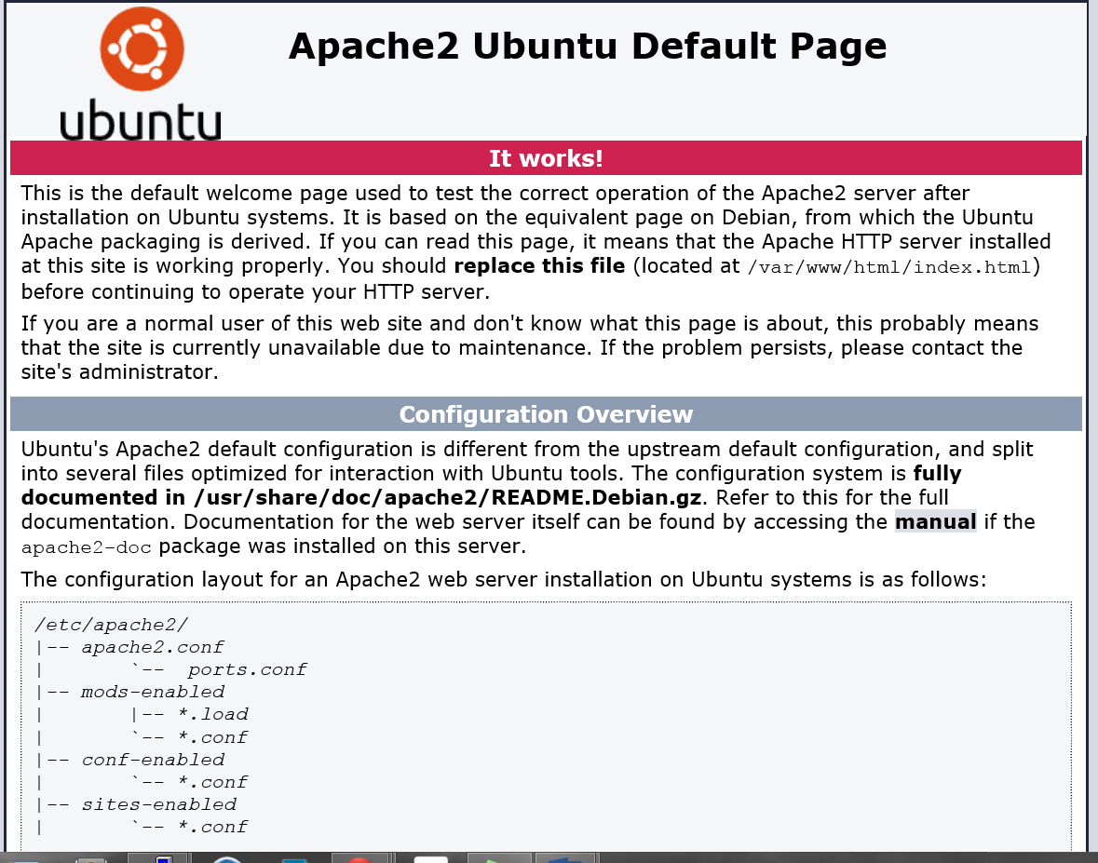

*Apache working*